

Subscribe to DeepL Pro to edit this document.  
Visit [www.DeepL.com/pro](https://www.deepl.com/pro?cta=edit-document)for more information.

FLEX/POSS Explanation

There are 2 types of switches within the received dataset: FLEX switches and POSS switches.  
**FLEX** includes the following signals:   
- Motor current (1 or more)   
- Control (1 or more)   
- Steering (1 or 2)   
- Switch occupation (1 or 2)

**POSS** includes the following signals:   
- Motor current (1 or more)   
- Position (1)

**FLEX** switches are the most complete and complex type of switches within PMP. All events in the "Event Type" and "Event Type Train" table are present. Important to mention is that in the received data you might find "999" as values. This means that there are no recorded values for this attribute.

**POSS** switches are less complex switches, since you have no steering, no control signals and no switch occupation signals many events cannot be calculated. The events that are left are simply switch events to the left/right and steering problems (position signals for POSS switches are considered steering signals).

**DATA**For every switch you have 2 datafiles:  
- PPLG$*number*_Motorflowdata.csv-   
PPLG$*number*_otherdata.csvPPLG$*number*   
indicates the area the switch is in accompanied by a simple number. For example UT$2615 is switch 2615 in the Utrecht area. The numbers arbitrary and do not stand for the amount of switches in that area or the Netherlands for that matter (Utrecht doesn't have 2615 switches).  
**_Motorflowdata** has all recorded values for all motor currents for the month of March and has the following columns- AssetName: The name of the asset, will be the same within a file, corresponds with .csv filename- Attribute: The specific attribute-   
Timestamp: The timestamp belonging to the data entry-   
Value: The recorded value for the data entry.   
Timestamp is in UTC Time format and UTC Time. Values are in doubles.

**_Otherdata** Has all the other recorded values for a switch which are relevant for this hackaton.   
The columns are the same with the exception that the column value is not always a double. Where possible values have been translated to strings to better show the meaning since translations differ per asset.

The tables on the following pages will help identifying and explaining the data, the results and how to get to the results. If something is unclear please ask.

Cases:  
  
1: Is there a relationship between weather and the operation of the switch? Weather data can be retrieved (.CSV) from [the](https://www.daggegevens.knmi.nl/) following websites, Weather conditions can modify the operation of the switch and/or result in changes in the use of the switch. Think of precipitation or temperature (snow / rain make the object work worse? and higher temperatures provide less resistance during circulation). It is up to you to retrieve the data from KNMI, link the data to points (find the nearest weather station) and create relationships.

<https://www.daggegevens.knmi.nl/>  
<https://www.knmi.nl/kennis-en-datacentrum/achtergrond/data-ophalen-vanuit-een-script>

2: Is there a relationship between the load/direction of the switch (and train) and the operation of the switch (based on WENS data).   
Acquired data includes time of day, switch preparation, load, train direction and axle counter information. One expectation is that heavy trains can drive a switch out of control le and perhaps multiple times. The theory behind this is that heavy trains can deform the switch such that the sensors/wires connected can lose contact and therefore the switch is briefly out of control. But you guys may link and examine the data in any way you want.

3: Is there a relationship between the location/substrate and the operation of the switch. Information can be found on the websites listed below. The assumption in this case is that switches may exhibit behavior that can be explained by the subgrade. The subgrade under each piece of track is solid, but it may be that the underlying subgrade is causing problems with turnarounds or changes in patterns. It is up to you to see if information about the subgrade can be used to explain behavior in turnouts.   
  
<https://www.pdok.nl/>

<https://www.nlog.nl/> (downloadable) and <https://www.dinoloket.nl/> (not downloadable).

4: Is there a relationship between the type of turnout and the operation of the turnout? This requires providing a small AMD of the switches we want it for. Turnouts such as coupled turnouts can be problematic. However, other relationships between turnout properties and turnout performance may also be investigated. Problems such as turnaround problems, spontaneous out of control problems and steering problems.

5: Can a problem with a bypass be recognized by previous bypasses? Relationships between problems and preceding orbits are difficult to establish, data which you can use are for example the summary values or the motor current signals. The data supply should be as complete as possible to give students as much information as possible to dig into.

Templates

|  |  |  |  |
| --- | --- | --- | --- |
| Templates - (*Visualization*) | FLEX/POSS | Coupled/Uncoupled | Number of switches* |
| 1.1.1 - (*0S,1S,2S*) | Flex | Unconnected | 115 |
| 1.1.22 | Flex | Unconnected | 3 |
| 2.1.3 - (*4S*) | Flex | Linked | 14 |
| 2.1.7 | Flex | Linked | 10 |
| 2.1.9 | Flex | Linked | 4 |
| 8A.1.15 | Flex | Linked | 4 |
| 11A.1.21 | Flex | Linked | 2 |
| 11B.1.14 | Flex | Linked | 4 |
| 13A.1.18 - (2S) | Flex | Unconnected | 4 |
| 13B.1.17 | Flex | Linked | 4 |
| 15A.1.10 | Flex | Unconnected | 2 |
| 15A.1.16 | Flex | Unconnected | 2 |
| 15B.1.20 | Flex | Linked | 6 |
| 17A.1.12 | Flex | Unconnected | 5 |
| 17B.1.14 | Flex | Linked | 4 |
| 20.1.6 - (*1S*) | Flex | Unconnected | 21 |
| 20.3.6 | PWM (POSS) | Unconnected | 16 |
| 1.2.31 | POSS | Unconnected | 1144 |
| 2.2.31 | POSS | Linked | 1600 |
| 3.2.31 | POSS | Unconnected | 17 |
| 6.2.31 | POSS | Linked | 6 |
| 6A.2.31 | POSS | Linked | 6 |
| 7.2.32 | POSS | Unconnected | 1 |
| 8A.2.31 | POSS | Linked | 174 |
| 12.2.33 | POSS | Unconnected | 1 |
| 13A.2.35 | POSS | Unconnected | 6 |
| 13A.2.38 | POSS | Unconnected | 2 |
| 14.2.37 | POSS | Unconnected | 2 |
| 15A.2.32 | POSS | Unconnected | 20 |
| 15B.2.31 | POSS | Linked | 10 |

Attributes

|  |  |  |  |
| --- | --- | --- | --- |
| Attributes[variants] | FLEX/POSS | Explanation | UFL |
| AlarmStatus |  |  |  |
| Number of alarms | FLEX/POSS | The total number of alarms for the past 8 hours on this switch. |  |
| Number of Warnings | FLEX/POSS | The total number of alerts for the past 8 hours on this switch. |  |
| Alarm Event [A/B] | FLEX/POSS | Alarm based on event type |  |
| StatusSW [A ;B ;A/B] | FLEX/POSS | Alarm/warning based on summary value |  |
| StatusSW Event | FLEX/POSS | Trigger for even frame if StatusSW is Alarm/Warning |  |
| Building Blocks |  |  |  |
| Control Mode [A ;B ; A/B] | FLEX | Control Mode has three outcomes: control Left Control Right and Out control |  |
| Motor Current Active [A ;B ; A/B] | FLEX/POSS | Motor Current Active is 1 when motor current is greater than 0. |  |
| Section Salvage [A ;B ; A/B] | FLEX/POSS | Do or Do not section ride |  |
| Control Mode [A ;B ; A/B] | FLEX |  |  |
| Event triggers |  |  |  |
| Timer Control Problem | FLEX | 5 second timer after motor current ends | UFL |
| Timer Spontaneously Off Control | FLEX | 20 second timer after switch is out of control | UFL |
| Timer Circulation Problem | FLEX/POSS | 15 second timer after motor current starts | UFL |
| Timer Steering Problem Start | FLEX | 15 second timer after control | UFL |
| Event Trigger | POSS | start and end signal of event | UFL |
| EventFrame |  |  |  |
| Event Type [A/B]. | FLEX/POSS | Returns the Event Type of the event |  |
| Event Type Train [A/B] | FLEX/POSS | Returns the Type of Event of the train occupancy event |  |
| Master data |  |  |  |
| Number of counters | FLEX/POSS | Quantity of switch counters |  |
| Contract area | FLEX/POSS | Contract area |  |
| Contract area code | FLEX/POSS | Code of the Contract Area |  |
| Equipment no(s) | FLEX/POSS | Equipment Number |  |
| GeoCode | FLEX/POSS |  |  |
| Corner ratio | FLEX/POSS | Angle ratio of the switch |  |
| Normal position | FLEX/POSS | Normal mode, L or R |  |
| Object type | FLEX/POSS | Type of Asset |  |
| Maintenance Contractor | FLEX/POSS | Responsible maintenance contractor for this asset |  |
| PMP ID | FLEX/POSS |  |  |
| PMP Change number | FLEX/POSS | Exchange number (e.g. ASD$133A/B) |  |
| PPLG | FLEX/POSS | Primary process leadership area (e.g., ASD). |  |
| PUIC ID | FLEX/POSS | Unique ID code of asset |  |
| Region | FLEX/POSS | The region where the switch is located |  |
| Status PMP Asset | FLEX/POSS | Status of the Asset (Active or Inactive) |  |
| Engineering Field | FLEX/POSS | The engineering field of the asset |  |
| Template | FLEX/POSS | Template number |  |
| Train protection system type | FLEX/POSS | Train protection system type |  |
| Changeover type (NSE / EBI) | FLEX/POSS | Type of changeover control (NSE or EBI) |  |
| Switch type | FLEX/POSS | Type of switch (e.g. GN or NGW) |  |
| X beginning | FLEX/POSS | X location of the asset |  |
| Y beginning | FLEX/POSS | Y location of the asset |  |
| Measurement data |  |  |  |
| Source of Data | FLEX/POSS | Indicates whether data comes from FLEX or POSS | UFL |
| IsMaintenance | POSS | Indicates whether switch is under maintenance | UFL |
| Control Links [...] | FLEX | Control signal left | UFL |
| Control Right [...] | FLEX | Control signal right | UFL |
| Motor current [...] | FLEX/POSS | Motor current signal | UFL |
| MsgCounter | POSS | Number of the message sent | UFL |
| Position Change | POSS | Position signal whether switch goes left or right | UFL |
| Steering Links [...] | FLEX | Control signal to the left | UFL |
| Steering Right [...] | FLEX | Control signal to the right | UFL |
| Temperature | POSS | Temperature of motor | UFL |
| Summary Value |  |  |  |
| End motor current control left | FLEX | Time between end of motor current and left in control (s) |  |
| End engine current-check Right | FLEX | Time between end of motor current and right in control (s) |  |
| Energy surface Left [...] | FLEX/POSS | Area of motor current vs. time (Axis) |  |
| Energy Surface Right [...] | FLEX/POSS | Area of motor current vs. time (Axis) |  |
| Entrance Peak Left [...] | FLEX/POSS | The highest value of the motor current from the start until 0.4 sec after (A) |  |
| Entrance Peak Right [...] | FLEX/POSS | The highest value of the motor current from the start until 0.4 sec after (A) |  |
| Max Bypass Current Left [...] | FLEX/POSS | The highest value of the motor current after 0.4 sec to the end event (A) |  |
| Max Bypass Current Right [...] | FLEX/POSS | The highest value of the motor current after 0.4 sec to the end event (A) |  |
| Turnaround Time Left Motor Current [...] | FLEX/POSS | Duration of a motor current during an event (s) |  |
| Turnaround time Left Relay | FLEX | Duration of total event (s) |  |
| Turnaround Time Right Motor Current [...] | FLEX/POSS | Duration of a motor current during an event (s) |  |
| Turnaround time Right Relay | FLEX | Duration of total event (s) |  |
| Section Occupation Time | FLEX/POSS | Duration of train occupancy (s) |  |
| Time Controlled Motor Current Left | FLEX | Time between control signal and motor current start (s) |  |
| Time Controlling Current Right | FLEX | Time between control signal and motor current start (s) |  |
| Off Control Time to the left | FLEX | Time that control mode is out of control during the event (s) |  |
| Off Control Time to Right | FLEX | Time that control mode is out of control during the event (s) |  |

Event Types

|  |  |
| --- | --- |
| Type of Event |  |
| Type of Event |  |
| Circulation to the Left | EV1 |
| Circulation to the Right | EV2 |
| Return right during circulation to left | EV6 |
| Return left during circulation to right | EV5 |
| Section Occupation during Circulation to Links | EV7 |
| Section occupation during circulation to Right | EV8 |
| Steering problem Left | EV17 |
| Steering problem Right | EV18 |
| Bypass problem Left | EV19 |
| Turn over problem Right | EV20 |
| Check problem Left | EV21 |
| Control Problem Right | EV22 |
| Spontaneous Off Control Left | EV11 |
| Spontaneous Off Control Right | EV12 |
| Cranks to the left | EV9 |
| Cranks to the Right | EV10 |
| Motor current without control | EV25 |
| Unknown | EV0 |
| Type of Event Train |  |
| Switch assignment Left | EV23 |
| Switch assignment Right | EV24 |
| Switch assignment left short out of control | EV13 |
| Switch assignment on the right briefly out of control | EV14 |
| Switch assignment on the left permanently out of control | EV15 |
| Turnout assignment on the right permanently out of control | EV16 |

Event Type (switch) decision diagram  
  
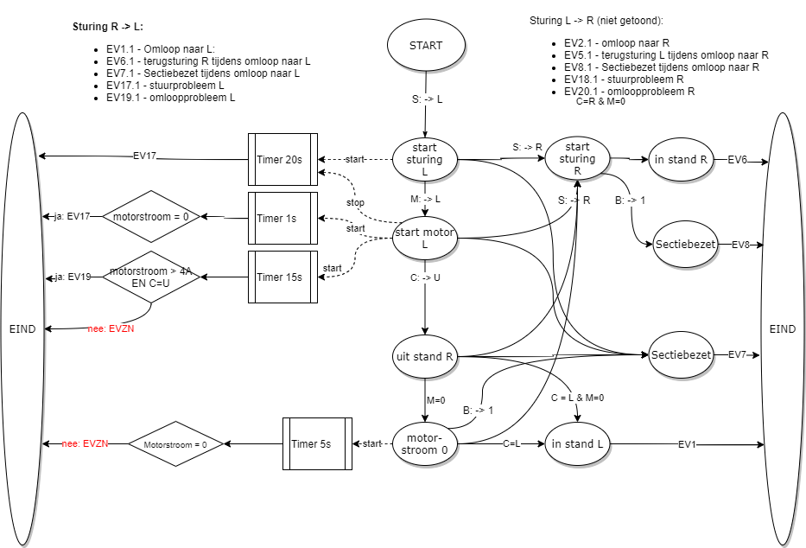

Event Type (Switching occupancy) decision diagram

